**Case Study 3:**

**E – Learning Platform**

A Case Study Presented to Professor Joseph C. Lorilla in Fulfillment of the Requirements in Object Oriented Programming

 BACHELOR OF SCIENCE IN COMPUTER SCIENCE

Sabando, Nelann Lloyd

Eramis, Angelou

Jamco, Ashley



**Description:**

The E-Learning Platform program uses a modular design with classes to manage different parts of the system and database to store data of the system. The Exam, Assignment, and Quiz classes track academic activities like exams taken, assignments submitted, and quizzes completed. Each class has methods to display, update, and increment these counts.

The Course class handles course details, including the total number of courses and their types. Static methods show this information, while class methods allow updates. The Enrollment class tracks student enrollments, with methods to display and adjust the enrollment count.

User management is handled by the Instructor, PlatformAdmin, and Student classes. The Instructor class tracks the number of instructors, while the PlatformAdmin class manages the platform name and admin count. The Student class monitors the total students and their account connections. The Grade class tracks student grades to ensure progress monitoring.

This program structure provides a solid framework for managing an e-learning platform, with clear separation of responsibilities and scalable methods for handling users, courses, and academic activities.

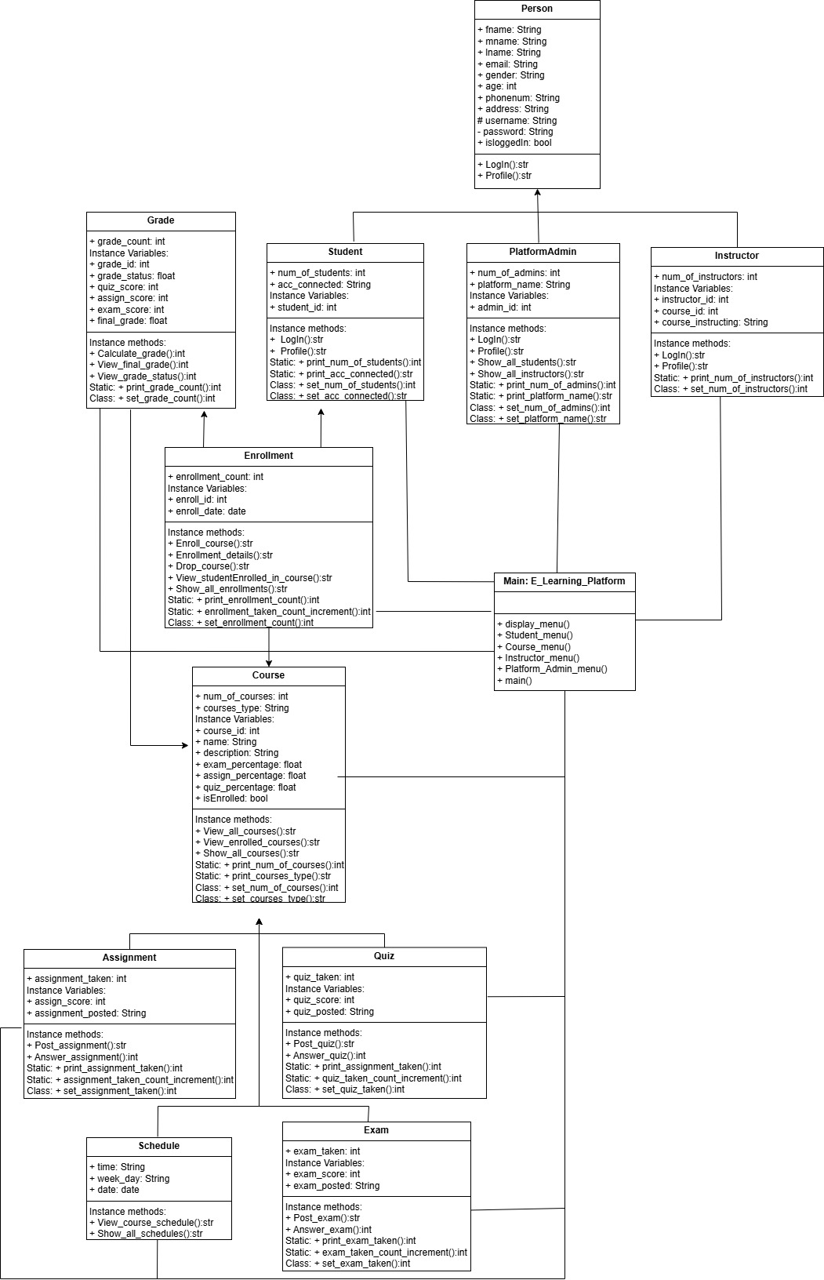**Class Diagram:**

The E-Learning Platform program is structured into several classes that manage different aspects of the system.

At the core, there is a Person class, which serves as a general blueprint for Students, Instructors, and PlatformAdmun. This class includes basic information like name, email, username, and login status. Students have specific details such as the number of students and account connectivity. They can also log in and access their profile. Instructors, on the other hand, manage the courses they are instructing.

The Enrollment class keeps track of student enrollments, with details like the course enrolled in and enrollment date. Course manages the courses available on the platform, including the course name, description, and associated percentages for assignments, exams, and quizzes. Instructors can manage courses, while students can enroll or drop courses.

The Assignment, Quiz, and Exam classes focus on academic activities. Each tracks how many assignments, quizzes, and exams have been taken, with additional details like scores and posted content. Methods allow students to submit assignments, take quizzes, and answer exams. They also manage counts for how many tasks have been completed.

The Grade class tracks students' grades, including scores for assignments, quizzes, and exams. The Schedule class handles the scheduling of courses and exams.

PlatformAdmin manages the overall platform, overseeing the number of admins and platform-related settings like its name.

Together, these classes form a complete e-learning system, where Students can enroll in multiple courses, take assignments, quizzes, and exams, and receive grades. Instructors can create and manage courses, while Admins oversee the platform’s operation and manage user roles.

**Code Snippets:**

**User Management**

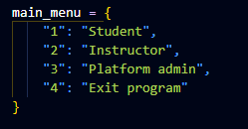

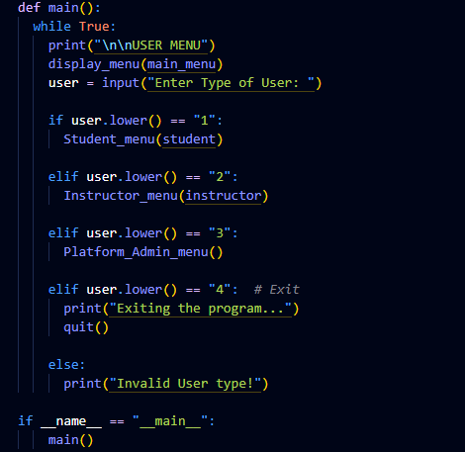

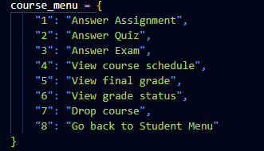**Course Manager**

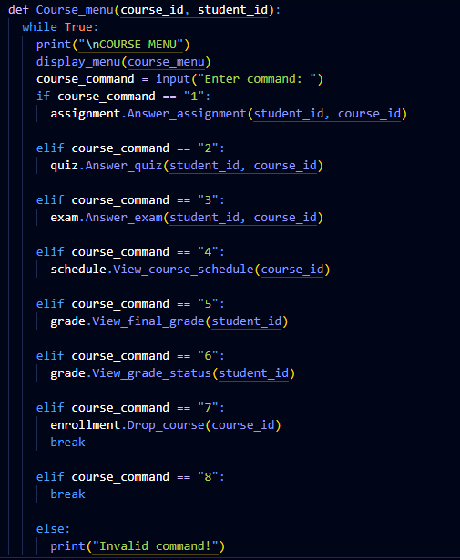

**Enrollment Manager**

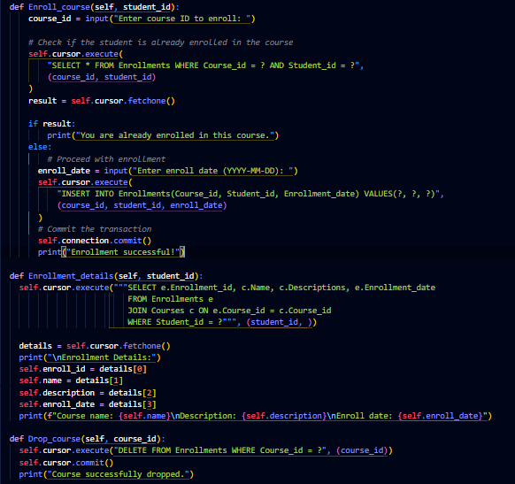

**Access modifiers**

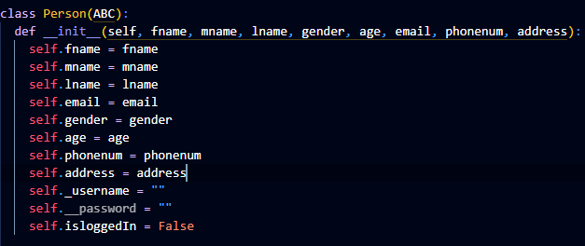

**Sample static methods**

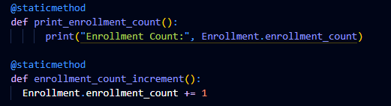

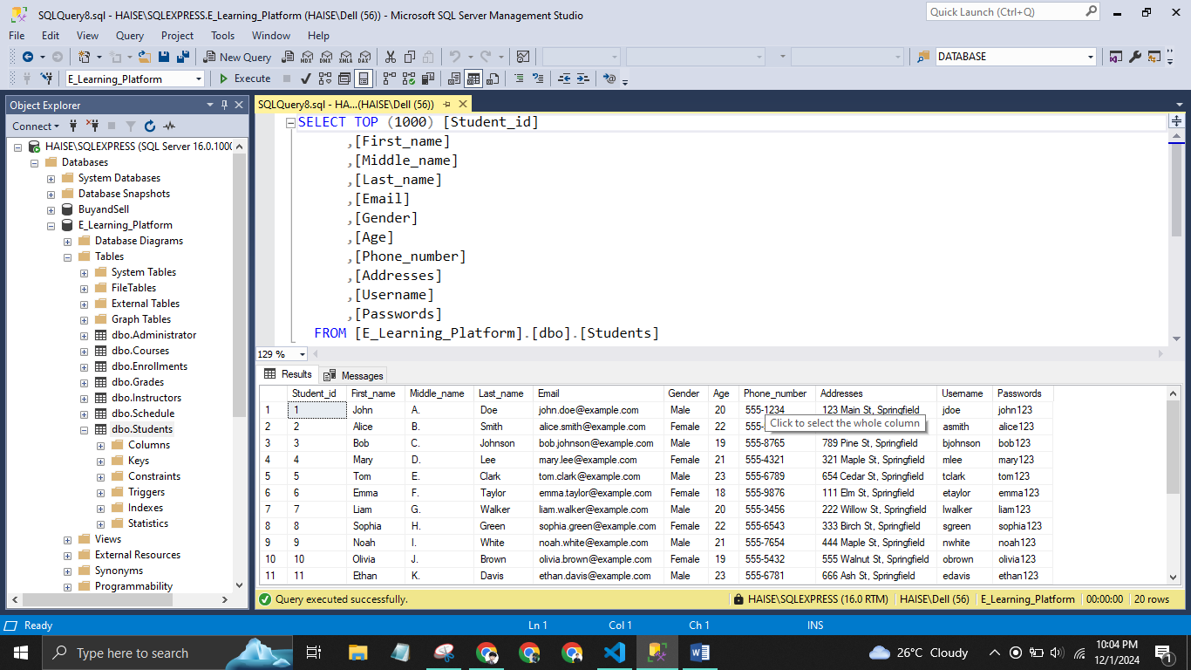**Data storage**